Question 1:

The convergents and partial quotients for the examples given are in the appendix. The program used basically uses the prescribed algorithm for the a_{n} and the x_{n}, using long division as we are computing the forms for rationals, so we can ensure that this is the exact form using integer arithmetic (inherently, floating point division incurs inaccuracy). Note that p_{n}/q_{n} = u/v is a test that checks out on all of the given examples.
For the complexity of the code, I’d say it is in O(Int(u/v)-log(Frac(u/v))), the reasoning behind this is in the appendix. (Note: ‘Int’ is the integer part of a value, ‘Frac’ the fractional part)

Question 2:

Required matrix identity:

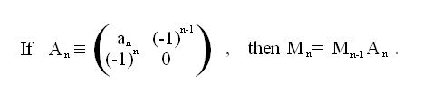
The implied result, derived by taking determinants and solving the recurrence relation, is:

p_{n}q_{n-1} – p_{n-1}q_{n} = (-1) ^{n-1}; - (*)

Basically, to obtain a program to find the highest common factor of u & v – hcf(u,v), and find the desired linear combination of these values, we see that p_{N}/q_{N} is u/v in it’s lowest terms (where these are the last convergents, indexed at n=N). If this were untrue then we must have some d in the integers dividing both p_{N} and q_{N} , by (*) we have contradiction on the RHS not being an integer but the LHS is. Thus this means the hcf(u,v) is u/p_{n}. Also, multiplying (*) evaluated at n=N by this hcf, we get:

Uq_{N-1} – Vp_{N-1} = (-1)^{N-1}hcf(u,v); - (**)

And multiplying this by -1 if necessary gives the required expression. So the only real modification the first program is finding when to multiply by this -1 and printing the correct expression. The answers to the examples are in the appendix.

Question 3:

The continued fraction algorithm is doing basically what Euclid does, but in a way more compatible with the computer. Firstly, when Euclid is running the division algorithm on u & v (take v < u wlog), this is exactly what each step of the continued fraction algorithm is doing – by taking the floors and getting the partial quotients, we get the term on each step of the division algorithm multiplying the quotient, and this is a_{n}. The running of Bezout after the division algorithm is used is different to what our algorithm does next, but gets the same final result. Bezout runs back up through the steps and back substitutes the lines of the division algorithm, keeping the hcf(u,v) on one side, and repeats until we get u & v on the RHS. The continued fraction algorithm finds all required values of the convergents, and due to the structure of the convergents’ formulae, we exploit that (p_{n}q_{n-1} – p_{n-1}q_{n}) = (-1)^{n-1} , increasing the index, n, until we get to the same equation as before, using p_{N} = u/hcf(u,v) & q_{N} = v/hcf(u,v). However, it is not until here that we get the hcf(u,v), whereas Euclid got it on the previous step.

Question 4:

To solve the congruence equation:

ax = b (mod m);

First we get hcf(a,m) by Euclid, then by Bezout, find integers r and s such that:

ar + ms = hcf(a,m); - (***)

The expression (***) gives the smallest linear combination of a & m (if not then there exists another divisor of a & m dividing hcf(a,m) non-trivially – contradiction). Thus, we can only get solutions for x iff hcf(a,m) divides b. Then we see that x = r*b/hcf(a,m) is a particular solution of the congruence equation. Then, since the full kernel of the function specified by multiplying by a in modulo m is {y є Z: y = 0 (mod m/hcf(a,m)) }, then the complete set of solutions is x = r*b/hcf(a,m) (mod m/hcf(a,m) ).

Question 5:

The solution set to the examples is in the appendix. Where there are no solutions, I have manually shown why. All the program does here is adapt the last program to find the values of r and m/hcf(a,m), tests to see if the hcf(a,m) divides b (if not, by the last question, we have no solutions), then gives the complete set of solutions as specified in the last question and using (**).

#Put in manual calculations too, especially finding the hcf of the 2nd example and explaining why this means there’s no soln (hcf not dividing b – I hope!)#

Question 6:

The proof that A₁ = A₂T^{n} for some integer n if A₁ and A₂ have equal left columns is in the appendix.
From question 2, we have that:

M_{n} = M_{n-1}A_{n} => M_{n} = M₋₁A₀A₁….A_{n-1}A_{n} , but the conditions on p_{n} & q_{n} for negative indices give M₋₁ = I, so =>

M_{n} = A₀A₁….A_{n-1}A_{n};

From here we set our M_{n} such that for the given element of SL₂(Z), the left columns are equal, that is, we designate values for p_{n} and q_{n}. From this, we find the continued fraction of p_{n}/q_{n} , i.e. the a_{n}. Thus we have gotten an expansion of M_{n} as a product of known, simpler matrices. Then we use that here, up to multiples of –I (which we ignore for now), S is equal to T^{n}A_{m} for some integer n up to overall sign (also proved in the appendix). If m is odd, we set n as a_{n} and it’s negative for the other parity. In the code, I have used the ‘a’ array to store these n, i.e. the indices of the T. Next, the –I factors must be accounted for, this is done simply in the code by seeing that there is a –I factor required to have equality up to T^{n} when n is even. So, looking at the product of the A_{n}, there will only be n overall –I when the number of A_{n}, i.e. N, is 0 or 1 in mod 4, as we get a sequence for N increasing from 1 like {-I,-I,I,I,-I,…} since (–I)(-I) = I. Finally, we see we have gotten an expansion of M_{n} as a product of A_{m}, and M_{n} and our element of SL₂(Z), so all we need do is apply the first result asked of in this question to find an M such that M_{n}T^{M} is our element (which exists by that proof). The code does that simply by just calculating how many additions of p_{n+1} are required to go from M_{n}’s top right element times (-1)^{N-1} to our element of Sl₂(Z)’s (which = M), and again, the proof of the first part ensures that division will give an int type here, so it is valid to do so. Then all that’s required is outputting it cleanly.
The results for the examples are:

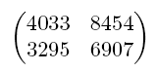
= TST⁻⁴ST²ST⁻⁶STST⁻¹ST²ST⁻¹⁰ST²;

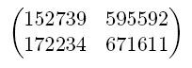
= -ST⁻¹ST⁷ST⁻¹ST⁵ST⁻¹⁹ST¹⁶ST⁻¹ST⁹ST⁴;

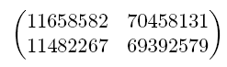
= -TST⁻⁶⁵ST⁸ST⁻¹¹ST⁸⁶ST⁻²³ST⁶.

Question 7:

On this computer, it is found that є = 2⁻⁵² ~ 10⁻¹⁶. Initially I found this by printing out the value which was specified as the epsilon for double floating point precision, “DBL_EPSILON”. This was checked via some code I wrote, that basically kept halving values (starting with 2) until 1 plus the current value was found to be 1, then the log₂ of this value was found by adding two to the negative of the amount of times the halving was done (output of this is in the appendix).
Onto the next part, firstly, I developed a routine to output the integer part of a floating point number (a double, specifically) as an int type. This is used in the algorithm for determining the a_{n}. Moving onto error considerations, the while loop which finds these a_{n} runs whilst keeping track on where the upper and lower bounds (in arrays xl_{n} and xu_{n} specifically) of the error expand to under the operations used, and on every subsequent storage of a value as a double type. Thus, when the bounds of x_{n} have different integer parts, then any further partial quotients must be deemed untrustworthy, since the inputted value is represented by a set (an open ball, radius epsilon, about the stored floating point value), and the ‘integer part of’ function can be multivalued on a the entire set, in the sense that, if we know a value is in (2.7,2.8) we know the calculated integer part is 2, whereas if it were in (2.7,3.1), we can’t know just based off the machine. Thus we stop there. Note that the program also ends if an x_{n+1} is calculated as 0, or otherwise on the next step there will be a division by zero. Also, note that I have adjusted this program to produce the partial quotients and convergents for the specific examples given and also, if ‘10’ is typed in first, for any other specific required value. One last thing to point out is that, given error automatically attained by storage, this program is not going to be good for finding the appropriate data for rationals, thus the first program should be used for that purpose.
Now, looking at the output, in some cases (i.e. π, 2π, π²), it is hard to guess how these repeated fractions would continue, as there is no obvious pattern, however, it’s very easy for others (i.e. e, e^{1/2}, 2e, ½(1+13^{1/2}) ). For example, in e, I’d say that a_{3n-1} = 2n for n>0 and every other a_{n} = 1 but a₀ = 2. Also, we have the one for ½(1+13^{1/2}) – almost all threes! (but this implies ½(3+13^{1/2}) has all threes). One very interesting, but oddly distributed in the partial quotient sequence, property is located in the continued fraction expansion of the irrational roots. There seems to be some sort of memory when a integer root is passed. I.e. something that changes in the expansion when you go from 3→5, 8→10 or 288→300, for example, as 4, 9 and 289 are 2², 3² and 17². For roots of two and three, there are periodic 2s in the expansion, for roots of integers between four and nine, there are periodic fours, from seventeen, there are periodic eights appearing. Moving down the line, up to two hundred and eighty nine, there are thirty-twos visible (they could appear later in the expansion) in most, but not all of the expansions, and after 289, there are always thirty-fours (note, these periodic, highlighted numbers, fit in with the pattern of being 2*a₀). One last thing I’d like to stress is that as you move from a square root to the next, the {a_{n}} sequences become less uniform (perfect uniformity being a constant sequence), with the spectrum of uniformity widening as the differences in consecutive square roots increase.
Finally, as I mentioned earlier, π, 2π and π² may not have very ‘memorable’ continued fractions, but as p_{n}/q_{n} → (the real) as n→∞, we can use the last convergents found as the best rational expansion possible here. There is of course, the infamous π ≈ 22/7, but these would be good too:

π ≈ 5419351/1725033;
2π ≈ 10838702/1725033;
π² ≈ 26140802/2648617.

And, although this is outside the scope of the project – nice, unforgettable rational approximations of π & 2π would be truncations of generalized continued fractions like:

π ≈ 3 + _______1________ or π ≈ _________4__________ 2π ≈ _______8______
6 + ______9______ 1 + _______1_________ 1 + _____1_____
6 + ____25____ 3 + ______4_______ 3 + ____4___
6 + ___49__ 5 + _____9_____ => 5 + __9__
6 + _81_ 7 + ___16___ 7 +_16_
6 +__ 9 + _25__ 9+__
… 11 + _ ...
...
(Simple pattern of squares ‘on-line’ terms in the first, second and third expansions, with constant 6s on the first and increasing odds on the other two non-‘on-line’ terms)

Appendix:

Results for question 1:

For 48/13:

n | a_{n} | p_{n} | q_{n}
0 | 3 | 3 | 1
1 | 1 | 4 | 1
2 | 2 | 11 | 3
3 | 4 | 48 | 13

For 4033/3295;

n | a_{n} | p_{n} | q_{n}
0 | 1 | 1 | 1
1 | 4 | 5 | 4
2 | 2 | 11 | 9
3 | 6 | 71 | 58
4 | 1 | 82 | 67
5 | 1 | 153 | 125
6 | 2 | 388 | 317
7 | 10 | 4033 | 3295

For 740785/516901:

n | a_{n} | p_{n} | q_{n}
0 | 1 | 1 | 1
1 | 2 | 3 | 2
2 | 3 | 10 | 7
3 | 4 | 43 | 30
4 | 5 | 225 | 157
5 | 6 | 1393 | 972
6 | 7 | 9976 | 6961
7 | 8 | 81201 | 56660
8 | 9 | 740785 | 516901

For 43360047/27537274:

n | a_{n} | p_{n} | q_{n}
0 | 1 | 1 | 1
1 | 1 | 2 | 1
2 | 1 | 3 | 2
3 | 2 | 8 | 5
4 | 1 | 11 | 7
5 | 5 | 63 | 40
6 | 1 | 74 | 47
7 | 2 | 211 | 134
8 | 1 | 285 | 181
9 | 2 | 781 | 496
10 | 1 | 1066 | 677
11 | 1 | 1847 | 1173
12 | 1 | 2913 | 1850
13 | 1 | 4760 | 3023
14 | 3 | 17193 | 10919
15 | 1 | 21953 | 13942
16 | 1 | 39146 | 24861
17 | 1 | 61099 | 38803
18 | 1 | 100245 | 63664
19 | 4 | 462079 | 293459
20 | 1 | 562324 | 357123
21 | 14 | 8334615 | 5293181
22 | 1 | 8896939 | 5650304
23 | 1 | 17231554 | 10943485
24 | 2 | 43360047 | 27537274

Results for question 2:

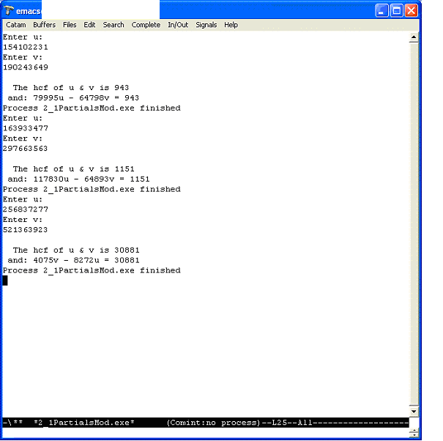

These results are easily verifiable and served as a good check to the program.

Results for question 4:

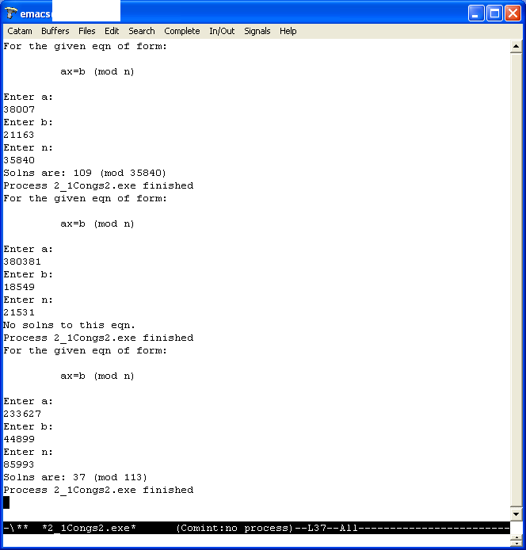

Printouts for question 6:

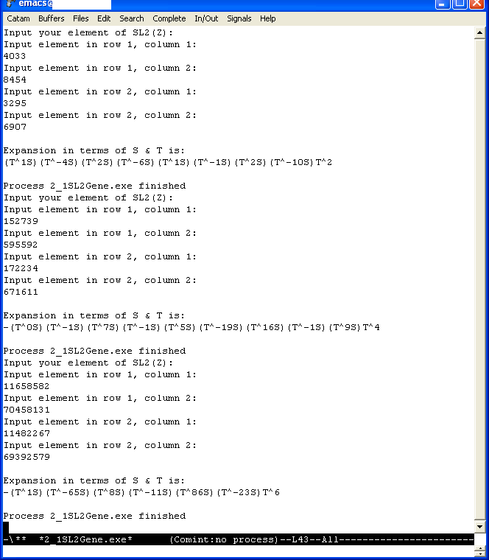

Epsilon for question 7:

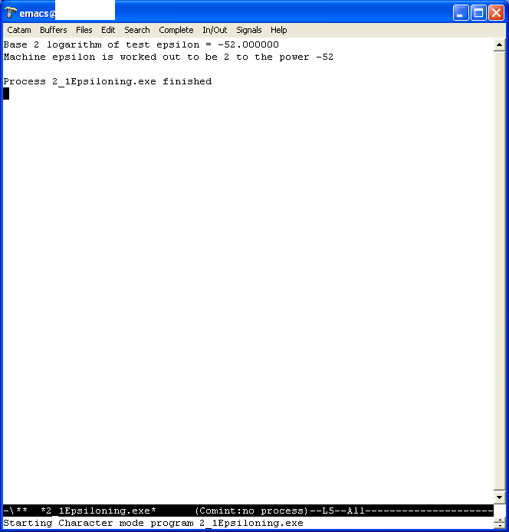

Table for question 7:

Value: | Continued Fraction expansion: | {p_{n}} | {q_{n}}
π | [3,7,15,1,292,1,1,1,2,1,3,1] | 3,22,333,355,103993,104348,  208341,312689,833719,1146408,  4272943,5419351 | 1,7,106,113,33102,33215,  66317,99532,265381,364913,1360120, 1725033
2π | [6,3,1,1,7,2,146,3,6,1,1,2] | 6,19,25,44,333,710,103993,312689,1980127, 2292816,4272943,10838702 | 1,3,4,7,53,113,16551,49766,315147, 364913,680060,1725033
π² | [9,1,6,1,2,47,1,8,1,1,2,2,1,1,8] | 9,10,69,79,227,10748,10975,98548,109523, 208071,525665,1259401,1785066,3044467, 26140802 | 1,1,7,8,23,1089,1112,9985,11097,21082, 53261,127604,180865,308469,2648617
e | [2,1,2,1,1,4,1,1,6,1,1,8,1,1,10,1,1, 12] | 2,3,8,11,19,87,106,193,1264,1457,2721,23225,25946,49171,517656,566827,1084483, 13580623 | 1,1,3,4,7,32,39,71,465,536,1001,8544, 9545,18089,190435,208524,398959,4996032
e^{1/2} | [1,1,1,1,5,1,1,9,1,1,13,1,1,17,1,1, 21] | 1,2,3,5,28,33,61,582,643,1225,16568,17793, 34361,601930,636291,1238221,26638932 | 1,1,2,3,17,20,37,353,390,743,10049, 10792,20841,365089,385930,751019, 16157329
2e | [5,2,3,2,3,1,2,1,3,4,3,1,4,1,3,6] | 5,11,38,87,299,386,1071,1457,5442,23225, 75117,98342,468485,566827,2168966,13580623 | 1,2,7,16,55,71,197,268,1001,4272,13817,18089,86173,104262,398959,2498016
3^{1/2}tan(1/3^{1/2}) | [1,7,1,3,1,19,1,7,1,31,1,11,1] | 1,8,9,35,44,871,915,7276,8191,261197,269388,3224465,3493853 | 1,7,8,31,39,772,811,6449,7260,231509, 238769,2857968,3096737
½(1+13^{1/2}) | [2,3,3,3,3,3,3,3,3,3,3,3,3,3,3] | 2,7,23,76,251,829,2738,9043,29867,98644, 325799,1076041,3553922,11737807,38767343 | 1,3,10,33,109,360,1189,3927,12970, 42837,141481,467280,1543321,5097243, 16835050
2^{1/2} | [1,2,2,2,2,2,2,2,2,2,2,2,2,2,2,2,2,2,2,2] | 1,3,7,17,41,99,239,577,1393,3363,8119,19601,47321,114243,275807,665857,1607521, 3880899,9369319,22619537 | 1,2,5,12,29,70,169,408,985,2378,5741, 13860,33461,80782,195025,470832, 1136689,2744210,6625109,15994428
3^{1/2} | [1,1,2,1,2,1,2,1,2,1,2,1,2,1,2,1,2,1,2,1,2,1,2,1,2,1] | 1,2,5,7,19,26,71,97,265,362,989,1351,3691, 5042,13775,18817,51409,70226,191861, 262087,716035,978122,2672279,3650401, 9973081, 13623482 | 1,1,3,4,11,15,41,56,153,209,571,780,2131,2911,7953,10864,29681,40545,110771, 151316,413403,564719,1542841,2107560,5757961,7865521
5^{1/2} | [2,4,4,4,4,4,4,4,4,4,4,4] | 2,9,38,161,682,2889,12238,51841,219602, 930249,3940598,16692641 | 1,4,17,72,305,1292,5473,23184,98209, 416020,1762289,7465176
6^{1/2} | [2,2,4,2,4,2,4,2,4,2,4,2,4,2,4] | 2,5,22,49,218,485,2158,4801,21362,47525, 211462,470449,2093258,4656965,20721118 | 1,2,9,20,89,198,881,1960,8721,19402, 86329,192060,854569,1901198,8459361
7^{1/2} | [2,1,1,1,4,1,1,1,4,1,1,1,4,1,1,1,4,1,1,1,4,1,1,1,4] | 2,3,5,8,37,45,82,127,590,717,1307,2024,9403, 11427,20830,32257,149858,182115,331973, 514088,2388325,2902413,5290738,8193151, 38063342 | 1,1,2,3,14,17,31,48,223,271,494,765, 3554,4319,7873,12192,56641,68833, 125474,194307,902702,1097009,1999711,3096720,14386591
8^{1/2} | [2,1,4,1,4,1,4,1,4,1,4,1,4,1,4,1,4,1,4,1] | 2,3,14,17,82,99,478,577,2786,3363,16238, 19601,94642,114243,551614,665857,3215042,3880899,18738638,22619537 | 1,1,5,6,29,35,169,204,985,1189,5741, 6930,33461,40391,195025,235416, 1136689,1372105,6625109,7997214
10^{1/2} | [3,6,6,6,6,6,6,6,6] | 3,19,117,721,4443,27379,168717,1039681,  6406803 | 1,6,37,228,1405,8658,53353,328776,  2026009
11^{1/2} | [3,3,6,3,6,3,6,3,6,3,6,3] | 3,10,63,199,1257,3970,25077,79201,500283, 1580050,9980583,31521799 | 1,3,19,60,379,1197,7561,23880,150841, 476403,3009259,9504180
12^{1/2} | [3,2,6,2,6,2,6,2,6,2,6,2,6] | 3,7,45,97,627,1351,8733,18817,121635,262087,1694157,3650401,23596563 | 1,2,13,28,181,390,2521,5432,35113, 75658,489061,1053780,6811741
13^{1/2} | [3,1,1,1,1,6,1,1,1,1,6,1,1,1,1,6,1,1,1,1,6,1,1,1,1] | 3,4,7,11,18,119,137,256,393,649,4287,4936, 9223,14159,23382,154451,177833,332284, 510117,842401,5564523,6406924,11971447, 18378371,30349818 | 1,1,2,3,5,33,38,71,109,180,1189,1369, 2558,3927,6485,42837,49322,92159,141481,233640,1543321,1776961,3320282, 5097243,8417525
14^{1/2} | [3,1,2,1,6,1,2,1,6,1,2,1,6,1,2,1,6,1,2,1] | 3,4,11,15,101,116,333,449,3027,3476,9979, 13455,90709,104164,299037,403201,2718243, 3121444,8961131,12082575 | 1,1,3,4,27,31,89,120,809,929,2667,3596, 24243,27839,79921,107760,726481, 834241,2394963,3229204
15^{1/2} | [3,1,6,1,6,1,6,1,6,1,6,1,6,1,6,1] | 3,4,27,31,213,244,1677,1921,13203,15124, 103947,119071,818373,937444,6443037,7380481 | 1,1,7,8,55,63,433,496,3409,3905,26839, 30744,211303,242047,1663585,1905632
17^{1/2} | [4,8,8,8,8,8,8,8] | 4,33,268,2177,17684,143649,1166876,9478657 | 1,8,65,528,4289,34840,283009,2298912
18^{1/2} | [4,4,8,4,8,4,8,4,8,4] | 4,17,140,577,4756,19601,161564,665857, 5488420,22619537 | 1,4,33,136,1121,4620,38081,156944, 1293633,5331476
19^{1/2} | [4,2,1,3,1,2,8,2,1,3,1,2,8,2,1,3,1,2] | 4,9,13,48,61,170,1421,3012,4433,16311,20744,57799,483136,1024071,1507207,5545692, 7052899,19651490 | 1,2,3,11,14,39,326,691,1017,3742,4759, 13260,110839,234938,345777,1272269, 1618046,4508361
20^{1/2} | [4,2,8,2,8,2,8,2,8,2,8,2] | 4,9,76,161,1364,2889,24476,51841,439204, 930249,7881196,16692641 | 1,2,17,36,305,646,5473,11592,98209, 208010,1762289,3732588
280^{1/2} | [16,1,2,1,2,1,32,1,2,1,2,1,32,1,2,1] | 16,17,50,67,184,251,8216,8467,25150,33617, 92384,126001,4124416,4250417,12625250, 16875667 | 1,1,3,4,11,15,491,506,1503,2009,5521, 7530,246481,254011,754503,1008514
281^{1/2} | [16,1,3,4,1,1,6,6,1,1,4,3,1,32,1] | 16,17,67,285,352,637,4174,25681,29855, 55536,251999,811533,1063532,34844557, 35908089 | 1,1,4,17,21,38,249,1532,1781,3313,15033,48412,63445,2078652,2142097
282^{1/2} | [16,1,3,1,4,1,3,1,32,1,3,1,4,1,3,1] | 16,17,67,84,403,487,1864,2351,77096,79447, 315437,394884,1894973,2289857,8764544, 11054401 | 1,1,4,5,24,29,111,140,4591,4731,18784, 23515,112844,136359,521921,658280
283^{1/2} | [16,1,4,1,1,1,3,10,1,15,1,10,3,1,1,1] | 16,17,84,101,185,286,1043,10716,11759, 187101,198860,2175701,6725963,8901664, 15627627,24529291 | 1,1,5,6,11,17,62,637,699,11122,11821, 129332,399817,529149,928966,1458115
284^{1/2} | [16,1,5,1,3,2,1,4,8,4,1,2,3,1,5,1] | 16,17,101,118,455,1028,1483,6960,57163, 235612,292775,821162,2756261,3577423, 20643376,24220799 | 1,1,6,7,27,61,88,413,3392,13981,17373, 48727,163554,212281,1224959,1437240
285^{1/2} | [16,1,7,2,7,1,32,1,7,2,7,1] | 16,17,135,287,2144,2431,79936,82367,656505,1395377,10424144,11819521 | 1,1,8,17,127,144,4735,4879,38888,82655,617473,700128
286^{1/2} | [16,1,10,3,3,2,3,3,10,1,32,1] | 16,17,186,575,1911,4397,15102,49703,512132,561835,18490852,19052687 | 1,1,11,34,113,260,893,2939,30283,33222,1093387,1126609
287^{1/2} | [16,1,15,1,32,1,15,1,32,1] | 16,17,271,288,9487,9775,156112,165887,  5464496,5630383 | 1,1,16,17,560,577,9215,9792,322559,  332351
288^{1/2} | [16,1,32,1,32,1,32,1,32,1] | 16,17,560,577,19024,19601,646256,665857, 21953680,22619537 | 1,1,33,34,1121,1155,38081,39236, 1293633,1332869
290^{1/2} | [17,34,34,34,34] | 17,579,19703,670481,22816057 | 1,34,1157,39372,1339805
291^{1/2} | [17,17,34,17,34] | 17,290,9877,168199,5728643 | 1,17,579,9860,335819
292^{1/2} | [17,11,2,1,3,8,3,1,2,11] | 17,188,393,581,2136,17669,55143,72812, 200767,2281249 | 1,11,23,34,125,1034,3227,4261,11749, 133500
293^{1/2} | [17,8,1,1,8,34,8,1,1,8] | 17,137,154,291,2482,84679,679914,764593, 1444507,12320649 | 1,8,9,17,145,4947,39721,44668,84389, 719780
294^{1/2} | [17,6,1,4,1,6,34,6,1,4,1] | 17,103,120,583,703,4801,163937,988423, 1152360,5597863,6750223 | 1,6,7,34,41,280,9561,57646,67207, 326474,393681
295^{1/2} | [17,5,1,2,3,2,6,2,3,2,1,5,34] | 17,86,103,292,979,2250,14479,31208,108103, 247414,355517,2024999,69205483 | 1,5,6,17,57,131,843,1817,6294,14405, 20699,117900,4029299
296^{1/2} | [17,4,1,7,1,4,34,4,1,7,1,4] | 17,69,86,671,757,3699,126523,509791,636314,4963989,5600303,27365201 | 1,4,5,39,44,215,7354,29631,36985, 288526,325511,1590570
297^{1/2} | [17,4,3,1,1,2,1,1,3,4,34,4,3,1,1,2] | 17,69,224,293,517,1327,1844,3171,11357, 48599,1663723,6703491,21774196,28477687, 50251883,128981453 | 1,4,13,17,30,77,107,184,659,2820,96539,388976,1263467,1652443,2915910, 7484263
298^{1/2} | [17,3,1,4,5,1,1,5,4,1,3,34,3,1] | 17,52,69,328,1709,2037,3746,20767,86814, 107581,409557,14032519,42507114,56539633 | 1,3,4,19,99,118,217,1203,5029,6232, 23725,812882,2462371,3275253
299^{1/2} | [17,3,2,3,34,3,2,3,34,3,2] | 17,52,121,415,14231,43108,100447,344449, 11811713,35779588,83370889 | 1,3,7,24,823,2493,5809,19920,683089, 2069187,4821463
300^{1/2} | [17,3,8,3,34,3,8,3,34] | 17,52,433,1351,46367,140452,1169983, 3650401,125283617 | 1,3,25,78,2677,8109,67549,210756, 7233253

Program Listing:

2_1Partials.c – Finds the continued fraction expansion of a rational and convergents;
2_1PartialsMod.c – Modification of the above to fine the hcf of two numbers and a specific linear combination of these values and the hcf;
2_1Congs2.c – Solves integer congruence relations;
2_1SL2Gene.c – Expresses elements of SL₂(Z) in terms of generators;
2_1RealPaApp.c – Finds the continued fraction expansion of a real and convergents in the general case and in specific examples;
2_1Epsiloning.c – Finds the value of the machine code epsilon on this computer.

2_1Partials.c:

#include <catam.h>

int uf,vf,i,j,I,U,V,a[1000],u[1000],v[1000],p[1002],q[1002];

int main(void) {

printf("Enter numerator:\n");
fflush(stdout);
scanf("%i",&uf);
printf("Enter denominator:\n");
fflush(stdout);
scanf("%i",&vf);

u[0]=uf;
v[0]=vf;

i=0,U=1;

while (U>0) {
U=u[i];
V=v[i];
I=0;
while (U>=V) {
U=U-V;
I=I+1;}
a[i]=I;
u[i+1]=V;
v[i+1]=U;

i=i+1;
}

/*Didn't divide once!! :D */

printf("\n");
printf("Continued fraction form of %i/%i is: ",uf,vf);
printf("[");
for(j=0;j<=i-2;j++) {
printf("%i,",a[j]);
}
printf("%i",a[i-1]);
printf("]\n\n");

printf("Convergents:\n");

p[0]=0,p[1]=1,q[0]=1,q[1]=0;

for(j=2;j<=i+1;j++) {
p[j]=a[j-2]*p[j-1]+p[j-2];
q[j]=a[j-2]*q[j-1]+q[j-2];
}

for (j=2;j<=i+1;j++) {
printf("p[%i]=%i q[%i]=%i\n",j-2,p[j],j-2,q[j]);
}
return 0;}

2_1PartialsMod.c:

#include <catam.h>

int uf,vf,i,j,I,U,V,hcf,a[1000],u[1000],v[1000],p[1002],q[1002];

int main(void) {

printf("Enter u:\n");
fflush(stdout);
scanf("%i",&uf);
printf("Enter v:\n");
fflush(stdout);
scanf("%i",&vf);

u[0]=uf;
v[0]=vf;

i=0,U=1;

while (U>0) {
U=u[i];
V=v[i];
I=0;
while (U>=V) {
U=U-V;
I=I+1;}
a[i]=I;
u[i+1]=V;
v[i+1]=U;

i=i+1;
}

p[0]=0,p[1]=1,q[0]=1,q[1]=0;

for(j=2;j<=i+1;j++) {
p[j]=a[j-2]*p[j-1]+p[j-2];
q[j]=a[j-2]*q[j-1]+q[j-2];
}

hcf=u[0]/p[i+1];

if (hcf==1) {printf("\n *u & v are coprime!*\n");}
else {printf("\n The hcf of u & v is %i\n",hcf);}

if (uf*q[i]-vf*p[i]>0) {printf(" and: %iu - %iv = %i",q[i],p[i],hcf);}
else {printf(" and: %iv - %iu = %i",p[i],q[i],hcf);}

return 0;}

2_1Congs2.c:

#include <catam.h>

int uf,vf,b,bh,k,n,B,i,j,I,U,V,hcf,soln,a[1000],u[1000],v[1000],p[1002],q[1002];

int main(void) {

printf("For the given eqn of form:\n\n");
printf(" ax=b (mod n) \n\n");

printf("Enter a:\n");
fflush(stdout);
scanf("%i",&uf);
printf("Enter b:\n");
fflush(stdout);
scanf("%i",&b);
printf("Enter n:\n");
fflush(stdout);
scanf("%i",&vf);

u[0]=uf;
v[0]=vf;

i=0,U=1;

while (U>0) {
U=u[i];
V=v[i];
I=0;
while (U>=V) {
U=U-V;
I=I+1;}
a[i]=I;
u[i+1]=V;
v[i+1]=U;

i=i+1;
}

p[0]=0,p[1]=1,q[0]=1,q[1]=0;

for(j=2;j<=i+1;j++) {
p[j]=a[j-2]*p[j-1]+p[j-2];
q[j]=a[j-2]*q[j-1]+q[j-2];
}

hcf=0,k=0;
while (u[0]>=p[i+1]) {
u[0]=u[0]-p[i+1];
hcf++;
}
B=vf;
while (B>=hcf) {
B=B-hcf;
k++;
}
B=b;
bh=0;
while (B>=hcf) {
B=B-hcf;
bh++;
}
if (B>0) {printf("No solns to this eqn.");}
else {
soln=(q[i]*bh+k)%k;
if (uf*q[i]-vf*p[i]>0) {
printf("Solns are: %i (mod %i)",soln,k);}
else {soln=(-soln+k)%k;
printf("Solns are: %i (mod %i)",soln,k);}
}
return 0;}

2_1SL2Gene.c:

#include <catam.h>

int M[2][2],m,n,i,j,f,I,U,V,a[1000],u[1000],v[1000],p[1000],q[1000];

int main(void) {

printf("Input your element of SL2(Z):\n");

for (m=0;m<=1;m++) {
for (n=0;n<=1;n++) {
int k;
printf("Input element in row %i, column %i:\n",m+1,n+1);
fflush(stdout);
scanf("%i",&k);
M[m][n]=k;
}
}
if (M[0][0]*M[1][1]-M[0][1]*M[1][0]==1) {

u[0]=M[0][0],v[0]=M[1][0];

i=0,U=1;

while (U>0) {
U=u[i];
V=v[i];
I=0;
while (U>=V) {
U=U-V;
I=I+1;}
a[i]=I;
u[i+1]=V;
v[i+1]=U;

i=i+1;
}

p[0]=0,p[1]=1,q[0]=1,q[1]=0;

for(j=2;j<=i+1;j++) {
p[j]=a[j-2]*p[j-1]+p[j-2];
q[j]=a[j-2]*q[j-1]+q[j-2];
}

I=ceil(i/2);

for (j=0;j<=I+2;j++) {
a[2*j+1]=-a[2*j+1];}

/*"i-1" is the value of N in a.*/

if (i%2==0) {
f=(M[0][1]-p[i])/p[i+1];}
else {f=(M[0][1]+p[i])/p[i+1];}

printf("\nExpansion in terms of S & T is:\n");

if ((i-1)%4==0) {printf("-");}
if ((i-1)%4==1) {printf("-");}

for (j=0;j<=i-1;j++) {
printf("(T^%iS)",a[j]);
}
printf ("T^%i\n",f);
}

else {printf("That's not in SL2(Z)!");}

return 0;
}

2_1RealPaApp.c:

#include <catam.h>

double epsilon;
double pi=3.1415926535897932;
double r,t,x[1000],xl[1000],xu[1000];

int a[1000],p[1000],q[1000],i,j,M,option;

int floint(double X) {
int I;
I=0;
while(X>0) {X=X-1;I=I+1;}
return I-1;}

int main(void) {

epsilon=pow(2,-52);

do {

printf("\nSelect which real to approximate via continued fractions:\n");
printf("1: pi,\n");
printf("2: 2*pi,\n");
printf("3: pi^2,\n");
printf("4: e,\n");
printf("5: e^1/2,\n");
printf("6: 2*e,\n");
printf("7: sqrt(3)*tan(1/sqrt(3)),\n");
printf("8: 1/2*(1+sqrt(13)),\n");
printf("9: *Or*, enter an non-square integer in [1,20]u[280,300] for square rooting\n and then finding the continued fraction of:\n");
printf("(Note: A square interger, n, has continued fraction form [n-1])");
printf("10: <Or>, enter a decimal to be approximated..\n\n");
fflush(stdout);
scanf("%i",&option);

switch(option) {
case 1:
r=pi;
xl[0]=(1-epsilon)*r;
xu[0]=(1+epsilon)*r;
x[0]=r;
break;
case 2:
r=pi;
xl[0]=(1-epsilon)*r;
xu[0]=(1+epsilon)*r;
xl[0]=(1-epsilon)*2*xl[0];
xu[0]=(1+epsilon)*2*xu[0];
x[0]=2*pi;
break;
case 3:
r=pi;
xl[0]=(1-epsilon)*r;
xu[0]=(1+epsilon)*r;
xl[0]=(1-epsilon)*pow(xl[0],2);
xu[0]=(1+epsilon)*pow(xu[0],2);
x[0]=pow(pi,2);
break;
case 4:
r=1;
xl[0]=(1-epsilon)*r;
xu[0]=(1+epsilon)*r;
xl[0]=(1-epsilon)*exp(xl[0]);
xu[0]=(1+epsilon)*exp(xu[0]);
x[0]=exp(1);
break;
case 5:
r=0.5;
xl[0]=(1-epsilon)*r;
xu[0]=(1+epsilon)*r;
xl[0]=(1-epsilon)*exp(xl[0]);
xu[0]=(1+epsilon)*exp(xu[0]);
x[0]=exp(0.5);
break;
case 6:
r=1;
xl[0]=(1-epsilon)*r;
xu[0]=(1+epsilon)*r;
xl[0]=(1-epsilon)*2*exp(xl[0]);
xu[0]=(1+epsilon)*2*exp(xu[0]);
x[0]=2*exp(1);
break;
case 7:
r=0.3333333333333333;
xl[0]=(1-epsilon)*r;
xu[0]=(1+epsilon)*r;
xl[0]=(1-epsilon)*(tan(sqrt(xl[0])))/sqrt(xl[0]);
xu[0]=(1+epsilon)*(tan(sqrt(xu[0])))/sqrt(xu[0]);
x[0]=tan(sqrt(r))/sqrt(r);
break;
case 8:
r=13;
xl[0]=(1-epsilon)*r;
xu[0]=(1+epsilon)*r;
xl[0]=(1-epsilon)*0.5*(1+sqrt(13));
xu[0]=(1+epsilon)*0.5*(1+sqrt(13));
x[0]=0.5*(1+sqrt(13));
break;
case 9:
printf("\n\n");
scanf("%lf",&t);
r=sqrt(t);
x[0]=r;
xl[0]=(1-epsilon)*t;
xu[0]=(1+epsilon)*t;
xl[0]=(1-epsilon)*sqrt(xl[0]);
xu[0]=(1+epsilon)*sqrt(xu[0]);
break;
case 10:
printf("\n\n");
scanf("%lf",&r);
x[0]=r;
xl[0]=(1-epsilon)*r;
xu[0]=(1+epsilon)*r;
break;
default:
printf("\nUnrecognized input :( ");
break;
}

M=0,i=0;

while (M==0) {

a[i]=floint(x[i]);
x[i+1]=1/(x[i]-a[i]);
xl[i+1]=1/(xu[i]-a[i]);
xu[i+1]=1/(xl[i]-a[i]);

xl[i+1]=xl[i+1]-epsilon*xl[i+1];
xu[i+1]=xu[i+1]+epsilon*xu[i+1];

if(floint(xl[i])!=floint(xu[i])) {M=1;}
if(i>0) {
if(x[i+1]==0) {M=2;}
}
i=i+1;
}

printf("\n\nContinued fraction form of this real is:\n");
printf("[");
for(j=0;j<=i-3;j++) {
printf("%i,",a[j]);
}
printf("%i]",a[i-2]);

printf("\n\nConvergents:\n");

p[0]=0,p[1]=1,q[0]=1,q[1]=0;

for(j=2;j<=i;j++) {
p[j]=a[j-2]*p[j-1]+p[j-2];
q[j]=a[j-2]*q[j-1]+q[j-2];
}

for (j=2;j<=i;j++) {
printf("p[%i]=%i q[%i]=%i\n",j-2,p[j],j-2,q[j]);
}

} while (option<10);

return 0;}

2_1Epsiloning.c:

#include <catam.h>
#include <float.h>

double e;
int f;

int main(void) {

e=log2(DBL_EPSILON);
printf("Base 2 logarithm of test epsilon = %lf\n",e);

e=2,f=0;
while (1+e!=1) {e=e/2;f--;}

printf("Machine epsilon is worked out to be 2 to the power %i\n",f+2);

return 0;}

